

DIGITAL ASSIGNMENT II

PROF SIVA RAMA KRISHNAN

GURJASH CHAWLA | 17BIT0039 | SLOT- D1

# QUESTION STATEMENT-

Host a website from a server and create a failover mechanism by implementing VMs

# **STEPS FOLLOWED DURING THE COMPLETION OF THE ASSIGNMENT** –

# STEP 1-

**Writing script for our website-**

For this particular assignment we have written a script for a website which host the clients who can create an account on our website and can extract information from it. The user can also comment in the particular blogs. We have used Nodejs for scripting and my personal laptop act as the server for the website.

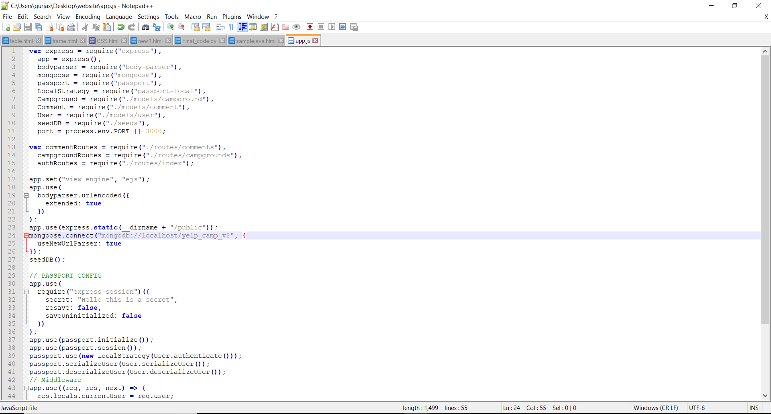

# STEP 2-

**Running our website-**

So after completion of writing of our script we ran our website with an local host and our laptop acting as a sever.

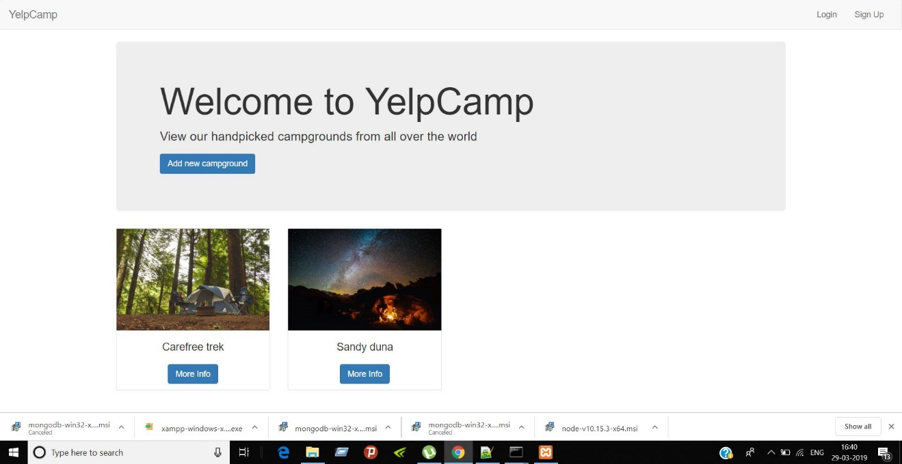

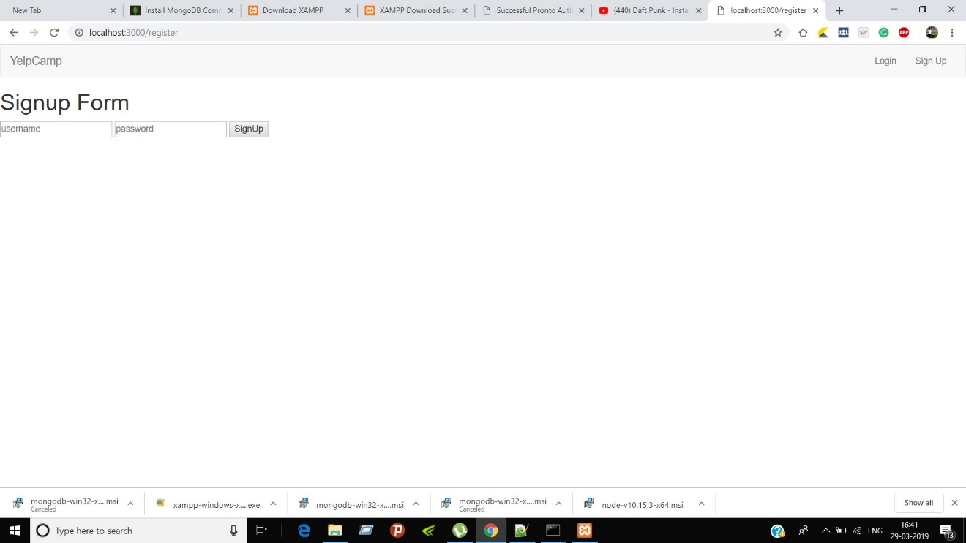

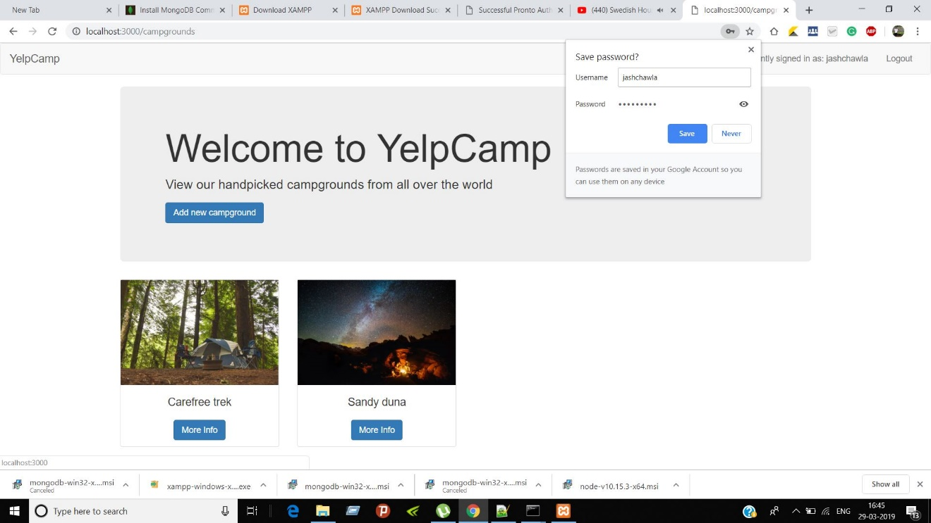

# STEP 3 –

**Setting up a Virtual Machine Using VM ware workstation pro 15**

For setting up the Virtual Machine we choose Ubuntu Operating system.

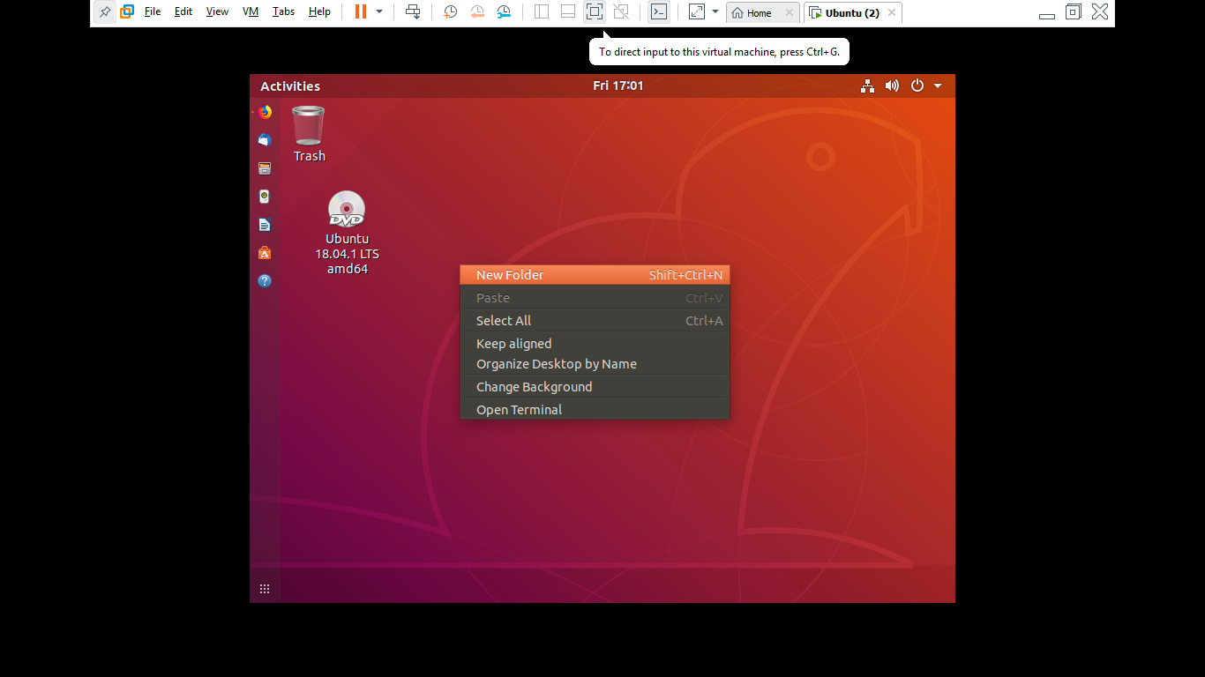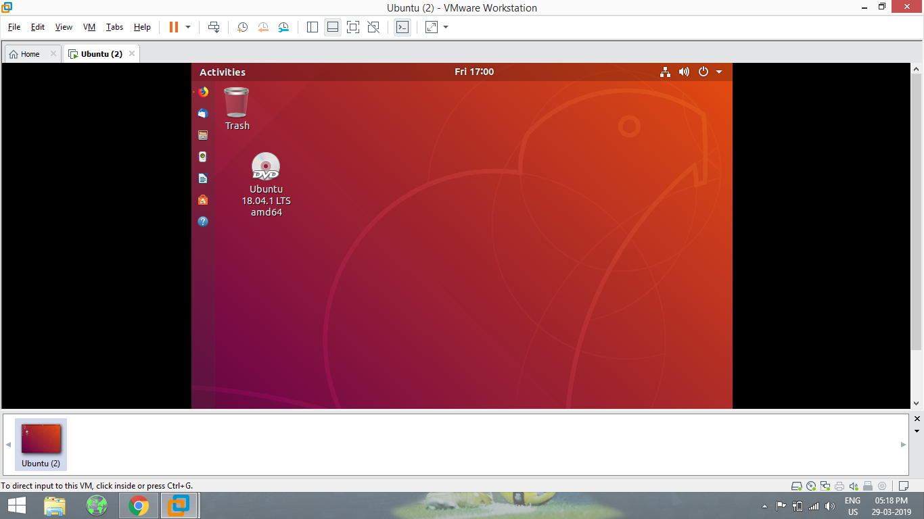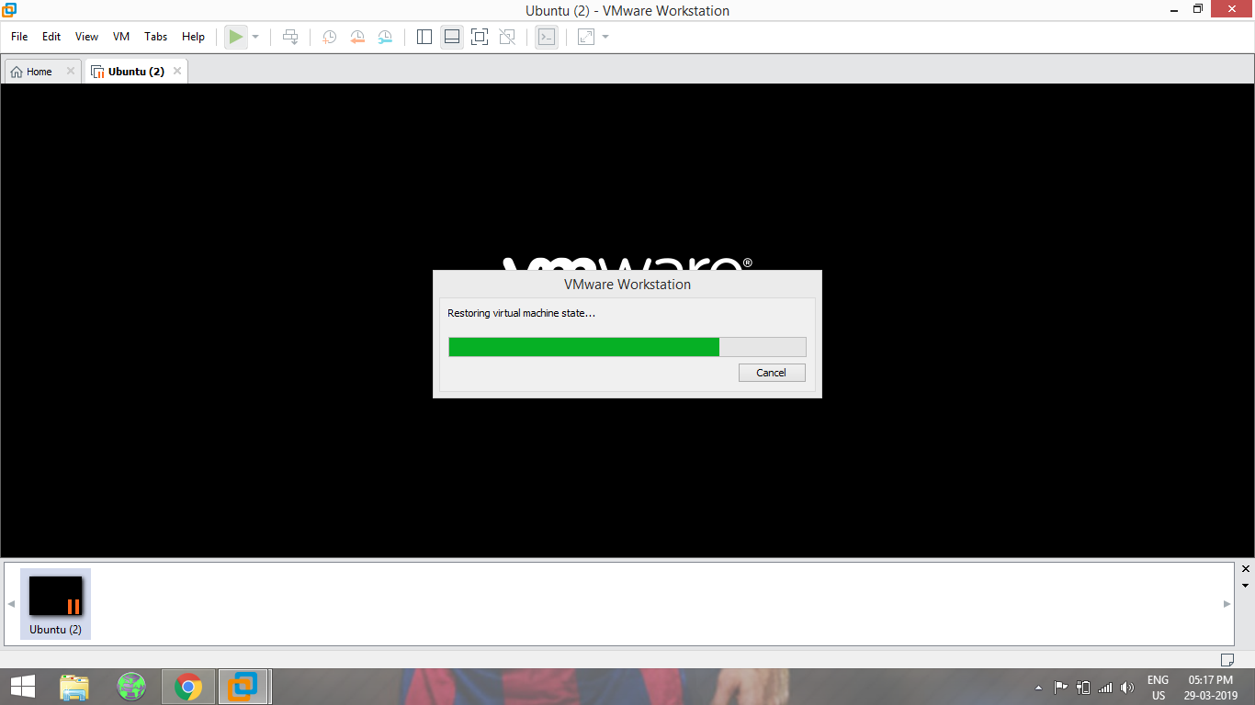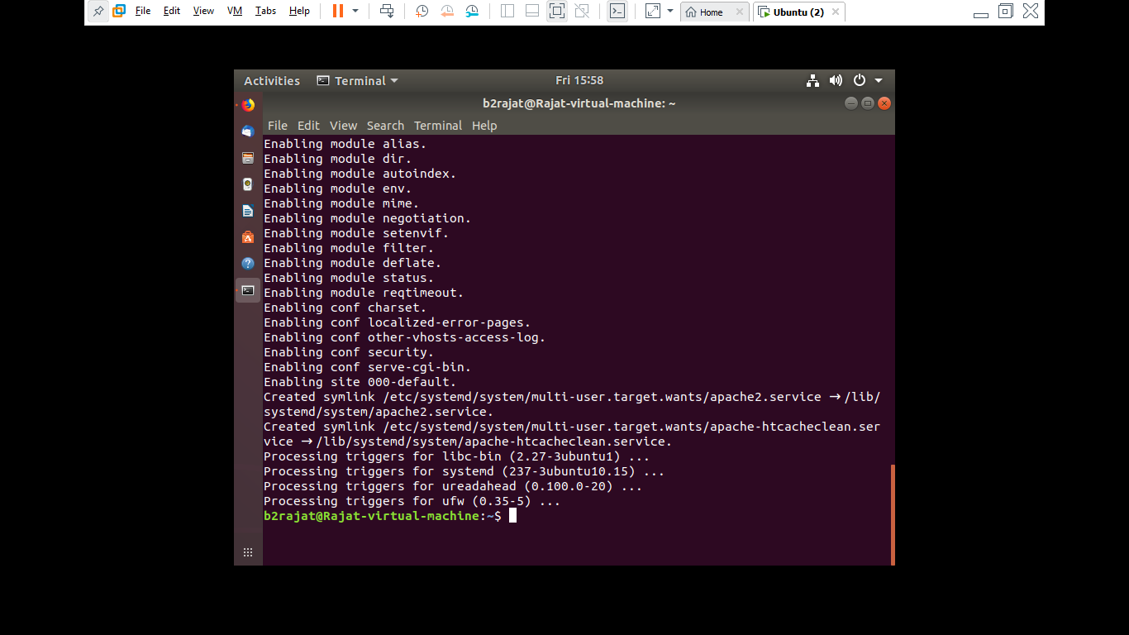

# STEP 4 –

**Running our website on the Virtual Machine-**

